DSA0601 • DATA HANDLING AND VISUALIZATION
Course Details | Information
Department | AIML
Course Code / Course Name | DSA0601 / Data Handling and Visualization
Programming / Visualization Tools | R / Tableau
Student Name | A Shiva Shankar Reddy
Register Number | 192425174
Date | 03-10-2026

SET 8: EMPLOYEE PERFORMANCE ANALYSIS

Experiment: Employee Performance Analysis

Aim
To visualize employee performance over years of service and department distribution using R charts, present employee performance data in a table, and develop a Tableau dashboard for interactive exploration.

Dataset: Employee Performance
Employee ID | Department | Years of Service | Performance Score
1 | Sales | 5 | 85
2 | HR | 3 | 92
3 | Marketing | 7 | 78

PROGRAM 1: Line Chart of Employee Performance
Create a line chart to visualize the performance score of employees over their years of service. Label the axes and title the chart.
years <- c(5, 3, 7)
performance <- c(85, 92, 78)
employee <- c("Employee 1", "Employee 2", "Employee 3")
order <- order(years)
plot(years[order], performance[order],
type = "o",
pch = 19,
xlab = "Years of Service",
ylab = "Performance Score",
main = "Employee Performance Trend Over Time")
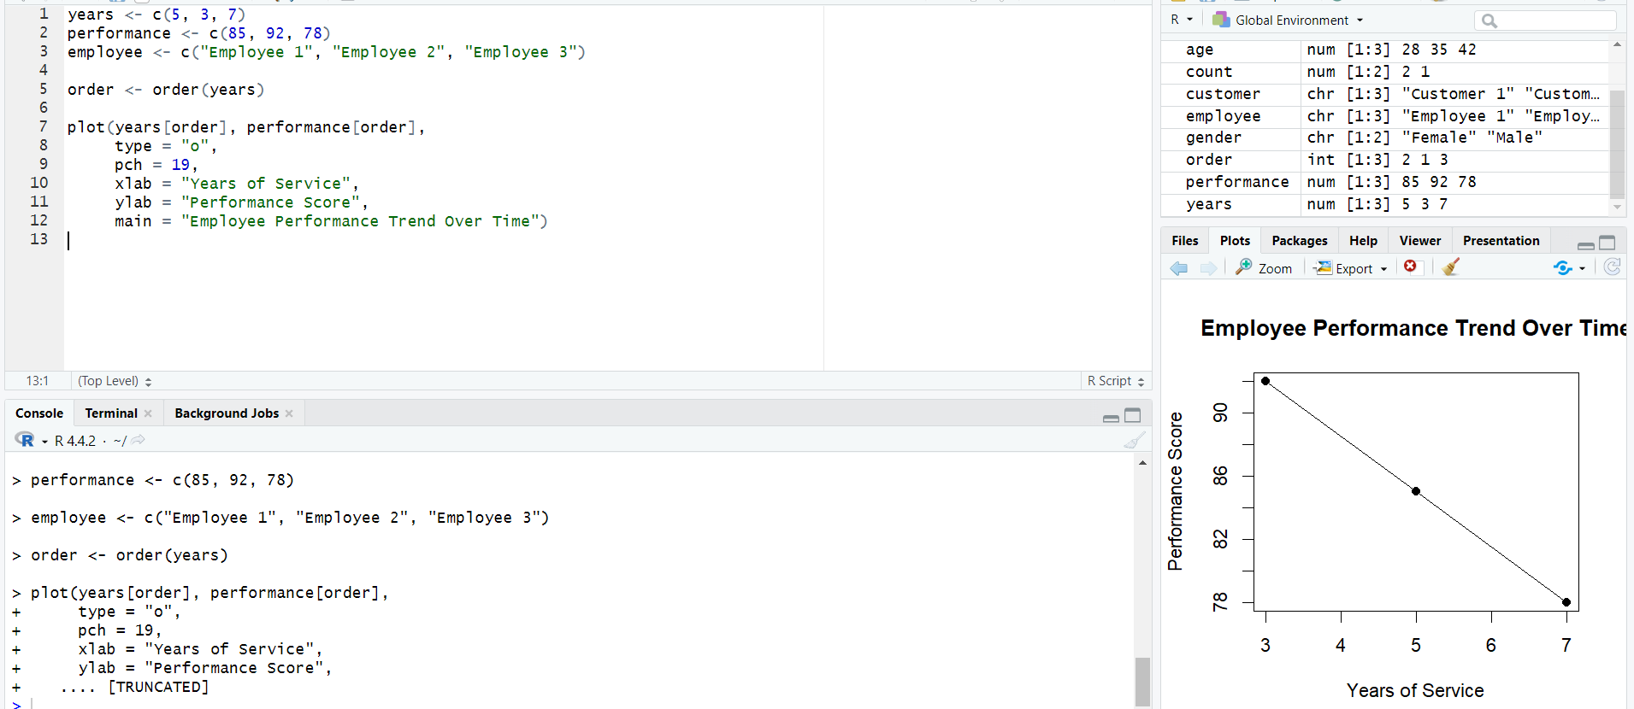
Figure 1: Line chart of performance score against years of service.
Observation: Among the three records, Employee 2 has the highest performance score (92), while Employee 3 has the lowest (78). The three observations do not establish a general performance trend because the dataset contains only three employees.

PROGRAM 2: Bar Chart of Department Distribution
Generate a bar chart showing the number of employees in each department. Label the chart elements.
department <- c("Sales", "HR", "Marketing")
employee_count <- c(1, 1, 1)
barplot(employee_count,
names.arg = department,
xlab = "Department",
ylab = "Number of Employees",
main = "Employee Distribution by Department",
col = "lightgreen")
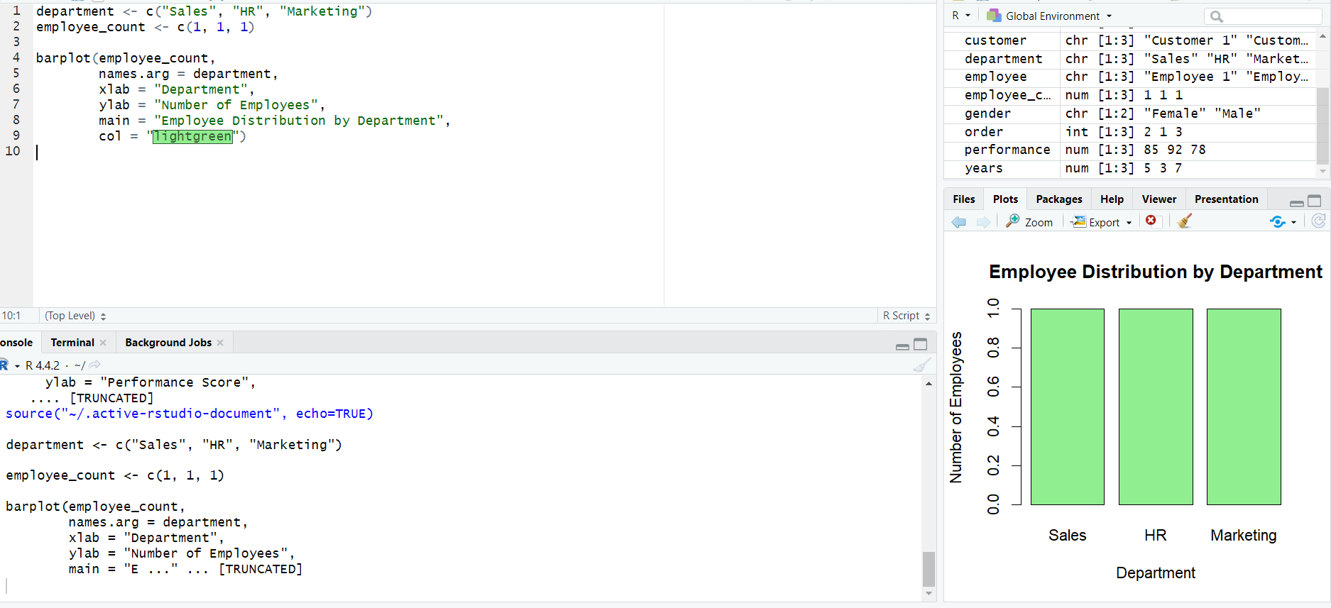
Figure 2: Bar chart showing employee count by department.
Observation: Each department contains one employee in the supplied dataset, so the department counts are equal.

PROGRAM 3: Employee Performance Table
Build a table to display the employee ID, department, years of service, and performance score.
employee_data <- data.frame(
Employee_ID = c(1, 2, 3),
Department = c("Sales", "HR", "Marketing"),
Years_of_Service = c(5, 3, 7),
Performance_Score = c(85, 92, 78)
)
employee_data
Employee ID | Department | Years of Service | Performance Score
1 | Sales | 5 | 85
2 | HR | 3 | 92
3 | Marketing | 7 | 78

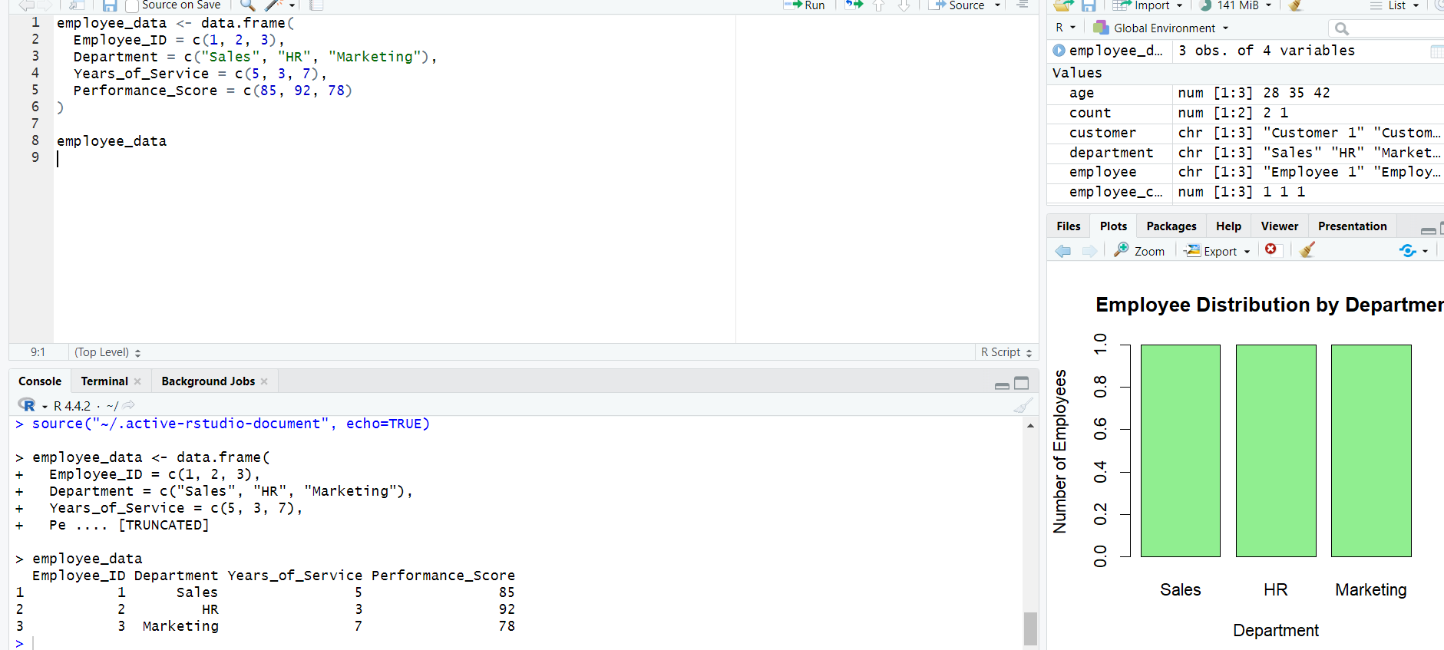Observation: The table provides a direct view of each employee's department, service duration, and performance score.

PROGRAM 4: Tableau Dashboard for Employee Performance
Develop a Tableau dashboard combining the performance line chart, department bar chart, and employee table for interactive exploration.
TABLEAU WORKFLOW
1. Connect Tableau to the Employee Performance dataset.
2. Worksheet 1 – Performance Line Chart:
• Years of Service → Columns
• Performance Score → Rows
• Employee ID → Detail / Label.
3. Worksheet 2 – Department Bar Chart:
• Department → Columns
• Employee ID → Rows as COUNT.
4. Worksheet 3 – Performance Table:
• Employee ID, Department, Years of Service, Performance Score → Text.
5. Create a new Dashboard and place all three worksheets on it.
6. Add Department and Employee ID filters.
7. Add dashboard actions for filtering or highlighting.
8. Add a dashboard title and save the Tableau workbook.
Observation: The dashboard brings together employee performance, department distribution, and detailed employee records for interactive analysis.

Procedure
- Create vectors for years of service and performance scores.
- Use plot() with type = 'o' to visualize performance over years of service.
- Use barplot() to show the number of employees in each department.
- Create a data frame and display the employee performance table.
- Create the line chart, department bar chart, and table in Tableau.
- Combine the worksheets into a dashboard and add filters or dashboard actions.

Result
The employee performance data was visualized using a line chart and department bar chart, displayed in a structured table, and combined into a Tableau dashboard for interactive exploration.

Key Functions / Tools Used
Function / Tool | Purpose
plot() | Creates the performance line chart.
barplot() | Creates the department distribution bar chart.
data.frame() | Creates a structured employee performance table.
Tableau | Creates interactive worksheets and dashboards.
Filters / Dashboard Actions | Enable interactive employee-performance exploration.

